

Eye Conjunctiva Sample



Palm Sample

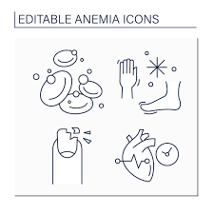

Fingernail Sample

**Database**



Pre-processing



Feature Selection



Deep-learning model



Performance Evaluation

Anemia

Non-Anemia

Output

**Figure 1.** Systematic Approach for detection of Anemia Disease

**Input Image**

Gray-scale based Deep Statistical Structural Edge Feature Extraction (GDSSE)

* Statistical filter based VGG19 features
* GLCM features
* Deep Edge based features
* Deep Structural flow based VGG19 features

Binary thresholding-based ROI Extraction

**Feature Concatenation**

Rank-based Feature selection

**Deep Global Pyramid Convolutional Neural Network**

Trained model

Anemia

Non-Anemia

Test data

**Pre-processing**

Output

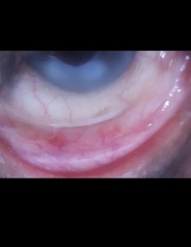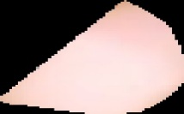

Eye Conjunctiva

Finger Nail

Palm

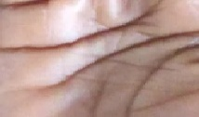

**Figure 2.** Schematic Representation of the Proposed DGPCNet for Anemia Detection

Weight layer

Weight layer

ReLu









**Figure 3.** General working of the Residual block



conv block

conv block

conv block

conv block













concat

concat

concat

conv block

conv block

conv block







concat





concat

conv block



conv block



concat

















Non-Anemia

Anemia

conv block

conv block1

conv block1

dropout

flatten

dense

dense

dense (softmax)

Output



Input layer 



Conv2d

activationn

maxpooln

dropout

Batch normalization

**Conv Block**

Conv2d

activationn

maxpooln

Batch normalization

**Conv Block 1**

dense

activationn

dropout

Batch normalization

**Dense**

Global Pyramid Network

Deep CNN



**Figure 4.** The architecture of the Deep Global Pyramid Convolutional Network

|  |  |  |  |  |
| --- | --- | --- | --- | --- |
| **Eyes-Defy-Anemia Dataset** | | | | |
| **Anemia** |  |  |  |  |
| Input | Preprocessing | VGG19 | Mean |
|  |  |  |  |
| Variance | Standard deviation | Skewness | Kurtosis |
|  |  |  |  |
| Energy | Dissimilarity | Homogeneity | Entropy |
|  |  |  |  |
| Contrast | ResNet 101 | Deep Edge | VGG19 |
|  | |  | |
| Structural flow | | Output | |
| **Non-Anemia** |  |  |  |  |
| Input | Preprocessing | VGG19 | Mean |
|  |  |  |  |
| Variance | Standard deviation | Skewness | Kurtosis |
|  |  |  |  |
| Energy | Dissimilarity | Homogeneity | Entropy |
|  |  |  |  |
| Contrast | ResNet 101 | Deep Edge | VGG19 |
|  | |  | |
| Structural flow | | Output | |

**Figure 5.** Classification of Anemia based on the Eyes-Defy-Anemia Dataset

|  |  |  |  |  |
| --- | --- | --- | --- | --- |
| **Anemia Detection using Palpable Palm Image Datasets from Ghana** | | | | |
| **Anemia** |  |  |  |  |
| Input | Preprocessing | VGG19 | Mean |
|  |  |  |  |
| Variance | Standard deviation | Skewness | Kurtosis |
|  |  |  |  |
| Energy | Dissimilarity | Homogeneity | Entropy |
|  |  |  |  |
| Contrast | ResNet 101 | Deep Edge | VGG19 |
|  | |  | |
| Structural flow | | Output | |
| **Non-Anemia** |  |  |  |  |
| Input | Preprocessing | VGG19 | Mean |
|  |  |  |  |
| Variance | Standard deviation | Skewness | Kurtosis |
|  |  |  |  |
| Energy | Dissimilarity | Homogeneity | Entropy |
|  |  |  |  |
| Contrast | ResNet 101 | Deep Edge | VGG19 |
|  | |  | |
| Structural flow | | Output | |

**Figure 6.** Classification of Anemia based on the Anemia Detection using Palpable Palm Image Datasets from Ghana

|  |  |  |  |  |  |
| --- | --- | --- | --- | --- | --- |
| **Detection of Anemia using Colour of the Fingernails Image Datasets from Ghana** | | | | | |
| **Anemia** |  |  |  |  |  |
| Input | Preprocessing | VGG19 | Mean | Variance |
|  |  |  |  |  |
| Standard deviation | Skewness | Kurtosis | Energy | Dissimilarity |
|  |  |  |  |  |
| Homogeneity | Entropy | Contrast | ResNet 101 | Deep Edge |
|  |  |  | | |
| VGG19 | Structural flow | Output | | |
| **Non-Anemia** |  |  |  |  |  |
| Input | Preprocessing | VGG19 | Mean | Variance |
|  |  |  |  |  |
| Standard deviation | Skewness | Kurtosis | Energy | Dissimilarity |
|  |  |  |  |  |
| Homogeneity | Entropy | Contrast | ResNet 101 | Deep Edge |
|  |  |  | | |
| VGG19 | Structural flow | Output | | |

**Figure 7.** Classification of Anemia based on the Detection of Anemia using Colour of the Fingernails Image Datasets from Ghana

|  |  |
| --- | --- |
|  |  |
| **Accuracy** | **Sensitivity** |
|  |  |
| **Specificity** | **Precision** |
|  |  |
| **FPR** | **FNR** |

**Figure 8.** Analysis of performance with the Ranking based Fused Features

|  |  |
| --- | --- |
|  |  |
| **Accuracy** | **Sensitivity** |
|  |  |
| **Specificity** | **Precision** |
|  |  |
| **FPR** | **FNR** |

**Figure 9.** Comparative results on the Eyes-Defy-Anemia Dataset with varying training percentage

|  |  |
| --- | --- |
|  |  |
| **Accuracy** | **Sensitivity** |
|  |  |
| **Specificity** | **Precision** |
|  |  |
| **FPR** | **FNR** |

**Figure 10.** Comparative results on the Anemia Detection using Palpable Palm Image Datasets from Ghana with varying training percentage

|  |  |
| --- | --- |
|  |  |
| **Accuracy** | **Sensitivity** |
|  |  |
| **Specificity** | **Precision** |
|  |  |
| **FPR** | **FNR** |

**Figure 11.** Comparative results on the Detection of Anemia using Colour of the Fingernails Image Datasets from Ghana with varying training percentage

|  |  |
| --- | --- |
|  |  |
| **Accuracy** | **Sensitivity** |
|  |  |
| **Specificity** | **Precision** |
|  |  |
| **FPR** | **FNR** |

**Figure 12.** Comparative results on the Detection of Anemia using the Ranking based Fused Features with varying training percentage

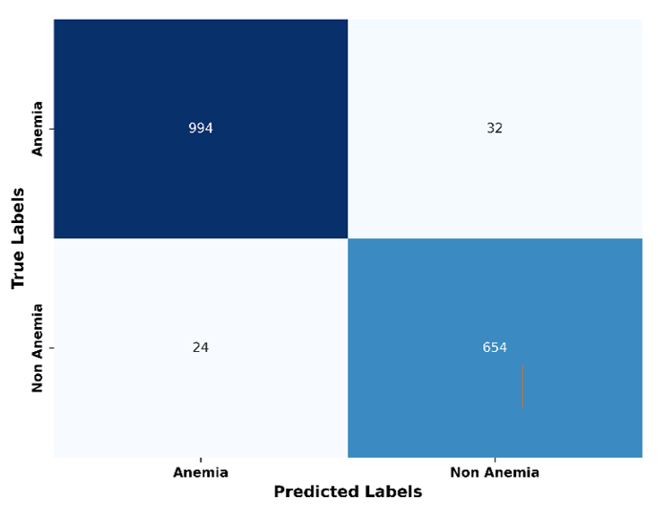

**Figure 13.** Confusion Matrix

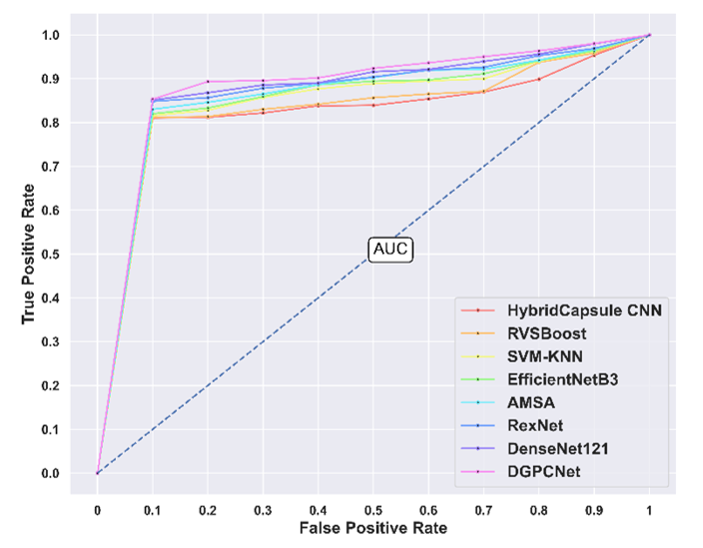

**Figure 14.** ROC Analysis

|  |  |
| --- | --- |
|  |  |
| **Accuracy** | **Sensitivity** |
|  |  |
| **Specificity** | **Precision** |
|  |  |
| **FPR** | **FNR** |

**Figure 15.** Comparative results with k-fold analysis on the Detection of Anemia using the Ranking based Fused Features

|  |
| --- |
|  |

**Figure 16.** Computation complexity Analysis

|  |
| --- |
|  |

**Figure 17.** Memory Usage Analysis

|  |  |
| --- | --- |
|  |  |
| Accuracy | Sensitivity |
|  |  |
| Specificity | Precision |
|  |  |
| FPR | FNR |

**Figure 18.** Comparative assessment based on Eyes-Defy-Anemia Dataset

|  |  |
| --- | --- |
|  |  |
| **Accuracy** | **Sensitivity** |
|  |  |
| **Specificity** | **Precision** |
|  |  |
| **FPR** | **FNR** |

**Figure 19**. Comparative assessment based on Palpable Palm Image Datasets from Ghana

|  |  |
| --- | --- |
|  |  |
| **Accuracy** | **Sensitivity** |
|  |  |
| **Specificity** | **Precision** |
|  |  |
| **FPR** | **FNR** |

**Figure 20**. Comparative assessment based on Colour of the Fingernails Image Datasets from Ghana

|  |  |
| --- | --- |
|  |  |
| **Accuracy** | **Sensitivity** |
|  |  |
| **Specificity** | **Precision** |
|  |  |
| **FPR** | **FNR** |

**Figure 21.** Comparative results on the Detection of Anemia using the Ranking based Fused Features with varying training percentage